International Bestseller and award-winning illustrator and author, Supriya Kelkar, is visiting our school!

Supriya will be signing books for our students. If you’d like to order her books to have them signed, please fill out this order form and turn it in to _______________________ by _______.
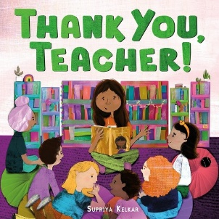
THANK YOU, TEACHER! (FSG/Macmillan) – out Feb. 25, 2025
A heartfelt picture book that says: Thank you, teacher, for everything you do.
The perfect gift for the wonderful educators in your life!
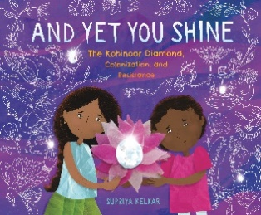
AND YET YOU SHINE: THE KOHINOOR DIAMOND, COLONIZATION, AND RESISTANCE (Candlewick) – 3rd grade and up. (April 2, 2024)
The story of one of the world’s most famous diamonds—stolen from South Asia during colonization and now among the crown jewels in London—is a call to action for readers to decolonize and hold their heads high.
“Exquisite, powerful, and deeply moving”—Christina Soontornvat, three-time Newbery Medal Honoree
“Exquisite illustrations” – School Library Journal, starred review
“A gem not to be missed” – Booklist, starred review
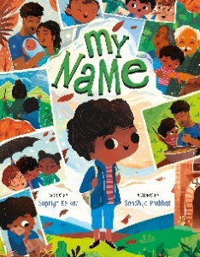
MY NAME (FSG/Macmillan) – ages 4+
- an inspiring picture book that encourages kids to celebrate themselves and all the things that make them unique, especially their name.
"The lyrical text is rhythmically pleasing and constructed to pointedly contrast the boy’s initial shame with the love, pride, and joy his name evokes." —School Library Journal, starred review
"After a school day of feeling that 'I'M DIFFERENT,' parental reassurances remind him that his name means he is cherished and wrapped 'together/ With those who came before.'" —Publishers Weekly
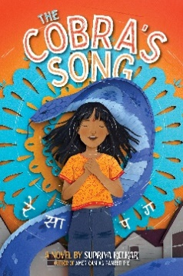
THE COBRA’S SONG (Simon & Schuster Books for Young Readers) – 3rd grade and up. From the author of American as Paneer Pie comes a magical adventure steeped in Indian folklore following a girl who learns how to find her voice and face her fears, perfect for fans of Aru Shah and Amina’s Song.
“An absorbing story that has music at its heart” – Kirkus Reviews
“Filled with Indian folklore and mythology and memorable characters, this voice-y middle-grade romp will be relatable to anyone who’s ever felt nervous about new experiences or family expectations.” – ALA Booklist
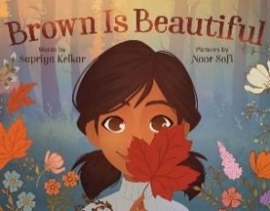
BROWN IS BEAUTIFUL (FSG/Macmillan) ages 4+- For fans of Hair Love and Eyes that Kiss in the Corners, here is an empowering picture book about recognizing the beauty around you and within you by award-winning author Supriya Kelkar and rising star illustrator Noor Sofi.
"A baby’s homecoming is a reminder of the joy found in the color brown, a cozy message that few readers will want to miss. Lovely." —School Library Journal

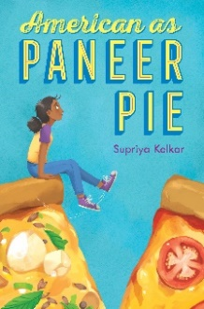
AMERICAN AS PANEER PIE (Aladdin/Simon & Schuster) 3rd grade & up- An Indian American girl navigates prejudice in her small town and learns the power of her own voice in this brilliant gem of a middle grade novel full of humor and heart.
- “[A] charming novel [that] explores the complexity of immigration and identity.” -TeenVogue
- “Addresses important issues of racism, colorism, and xenophobia through a well-drawn narrator whose political evolution is fascinating to watch.” —Kirkus Reviews
- “Ambivalence about one’s immigrant heritage…is sensitively explored in “American as Paneer Pie,” by Supriya Kelkar.” -The New York Times
- A School Library Journal Best Book of 2020

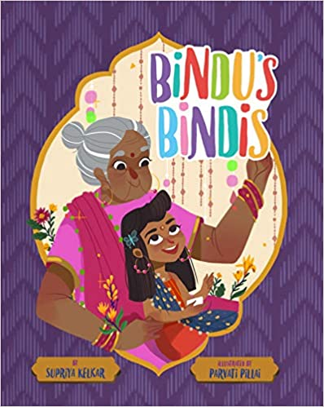
BINDU’S BINDIS – art by Parvati Pillai (Sterling) – Preschool & up - Bindu loves to match her bindis to her Nani’s. When Nani comes to visit Bindu and brings more bindis, it is just in time to wear something new to the school talent show. Bindu and Nani work together to shine their brightest and embrace their sparkle, even when they stand out from the crowd.
“A beautiful intergenerational tale” – Kirkus Reviews
“[a] sweet story of a little girl who just wants to be herself” – Booklist
“…warm storytelling and dazzling art…” – School Library Journal

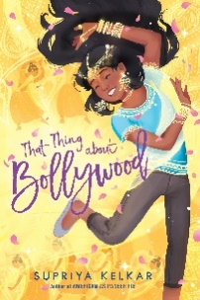
THAT THING ABOUT BOLLYWOOD (Simon & Schuster Books for Young Readers) 3rd grade & up - Bollywood takes over in this contemporary, magical novel about an Indian American girl whose world turns upside down when she involuntarily starts bursting into glamorous song-and-dance routines during everyday life.
“a tale with universal appeal through an engaging cultural lens. ” – Publisher’s Weekly
“This magical novel, full of bright color and Bollywood cultural flair, uses whimsy and humor to convey an important message about handling tough feelings.” – A Mighty Girl
“Kelkar… deftly draws out the impact divorce can have on friendships, schoolwork, and a child’s inner life.” – Horn Book

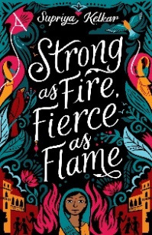
STRONG AS FIRE, FIERCE AS FLAME (Tu Books) – 4th grade & up - In 1857 India, 12-year-old Meera escapes a life she has no say in--and certain death on her husband's funeral pyre--only to end up a servant to a British general in the East India Company. When a rebellion against British colonizers spreads, she must choose between relative safety in a British household or standing up for herself and her people.
A 2021-2022 Read Across America Selection, The 2023 Global Read Aloud
“Meera's transformation from a complacent girl to embracing her spirited convictions is nothing short of inspiring.” – Booklist
“Meera’s transformation from scared child to bold revolutionary is especially gratifying…An absorbing story about a strong girl living during tumultuous times.” – Kirkus Reviews

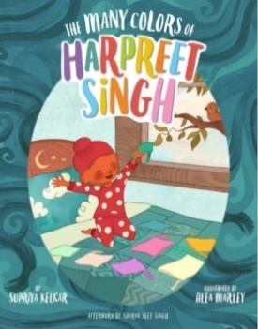
THE MANY COLORS OF HARPREET SINGH – words by Supriya Kelkar, illustrated by Alea Marley
“A lovely story about change and belonging”
– School Library Journal, starred review

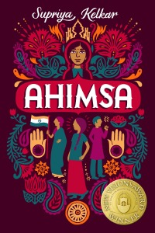
AHIMSA by Supriya Kelkar (Lee & Low Books) – 3rd grade and up
“Kelkar’s first middle-grade book is filled with female empowerment, hope, family, and the power of nonviolent resistance.” – Booklist, starred review.
“A historical, timely, and informative story”
– School Library Journal, starred review

